Finding a Physician:
- Use online Doctor Search service of The BC College of Physicians and Surgeons
- Phone the BC College of Physicians and Surgeons: (604) 733-7758

Community Clinics:
Clinic for refugees and immigrants
Bridge Community Health Clinic at Raven Song Community Health Centre, Ontario and 8th St, (604) 709-6540
Some Vancouver Inner City Clinics :
Three Bridges Community Health (604) 633 -4220
Pender Community Health (604) 669 – 9181
Vancouver Native Health (604) 255 – 9766
Victoria:
Pandora Clinic (250) 294 – 6714

MSP (CareCard) and PharmaCare:
- http://www.health.gov.bc.ca/msp/
- http://www.health.gov.bc.ca/msp/infoben/premium.html#regular
- Vancouver: 604 683-7151
- Other: (Toll-free) 1 800 663-7100
For questions about PharmaCare, Customer Service Representatives are available:
- Monday to Friday, 8:00 a.m. to 8:00 p.m. (except statutory holidays)
- Saturday 8:00 a.m. to 4:00 p.m. (except statutory holidays)
For questions about the Medical Services Plan (MSP), Customer Service Representatives are available:
- Monday to Friday, 8:00 a.m. to 4:30 p.m. (except statutory holidays)

For questions about your symptoms:
Call 8-1-1 to speak with a nurse any time of the day or night. You can also speak with a dietician on weekdays about nutrition and healthy eating. Pharmacists are available at night to answer medication questions.
Checklist of Questions when leaving an appointment:
- Do I understand what’s wrong?
- Do I know how to follow my treatment?
  - How many days?
  - How many pills per day?
  - Do I need to go to a pharmacy right now?
  - Do I need to go to the lab for blood work right now?
- Do I need to come back? If so, When?
  - Who do I make a follow-up appointment with?
- Did I write down the information I was given?

Common Symptoms:
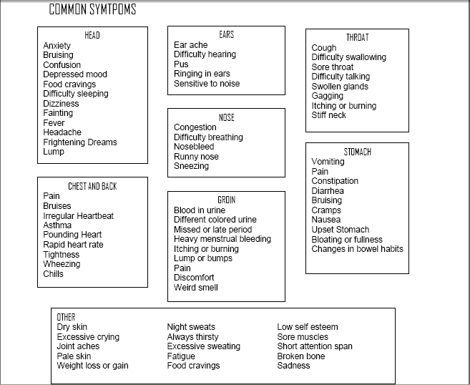

BC Bus Pass Program
- You will need to check to see if you are eligible first for this program.
- Provides an annual bus pass for $45/year (within a calendar year, ends on December 31 of each year) and need to reapply.
Website: http://www.mhr.gov.bc.ca/programs/other.htm
Phone: 1-866-866-0800 press extension 4, then press extension 3
Phone service is available Monday – Friday between 9:00am – 4:00pm. Please note that peak call volume occurs between 11:00am – 2:00pm each day.

Child Care Subsidy
- You will need to check to see if youa re eligible for this program
Website: http://www.mcf.gov.bc.ca/childcare/application.htm
Phone: 1 888 338-6622

Mental Health and Substance Abuse Resources:
HeretoHelp - a project by BC Partners for Mental Health and Addictions information: http://www.heretohelp.bc.ca/
Phone: 310-6789 (no area code required)

